Bernardo de Gálvez

Reawakens in Texas
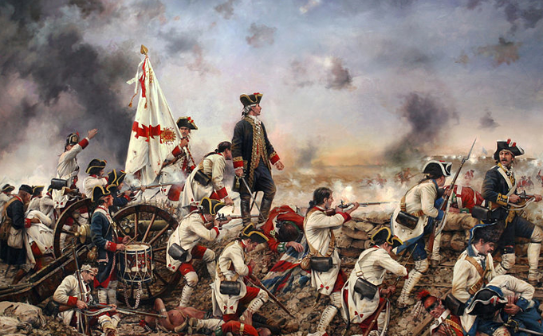

Remembering Galvez, a Threefold Tribute:
a FILM, an OPERA, and a STATUE

The contribution of Spain to the War of Independence, fighting in the South for the American cause, and Bernardo de Gálvez’s crucial role, all emerge forcefully through three enthusiastic initiatives in Texas.

These three initiatives will be presented to the public on:

November 13th, 2018 at 6 pm,
Embassy of Spain, Washington DC
2375 Pennsylvania Ave NW, Washington, DC 20037
First, the Film:
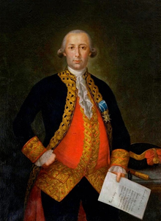

A docudrama about the heroic and passionate life of Bernardo de Gálvez, Governor of Spanish Louisiana, and the primary military player on the Spanish side of the American Revolution, is being produced by Native Sun Productions.

Directed by Gary Foreman, winner of major prizes for historical documentaries, the script is based on Gálvez/Spain Our Forgotten Ally in the Revolutionary War, a book by associate producer Edward Butler. Another associate producer is Jack Conan, founder of the “Texas Connection to the American Revolution” (TCARA,), and retired Spanish Ambassador, M.A.F. Mazarambroz served as Historical Advisor for the film. Texas A&M University and the Sons of American Revolution also collaborated on this project!

A trailer of the film will be shown at the Embassy at 6.30 PM.

Second, the Opera:

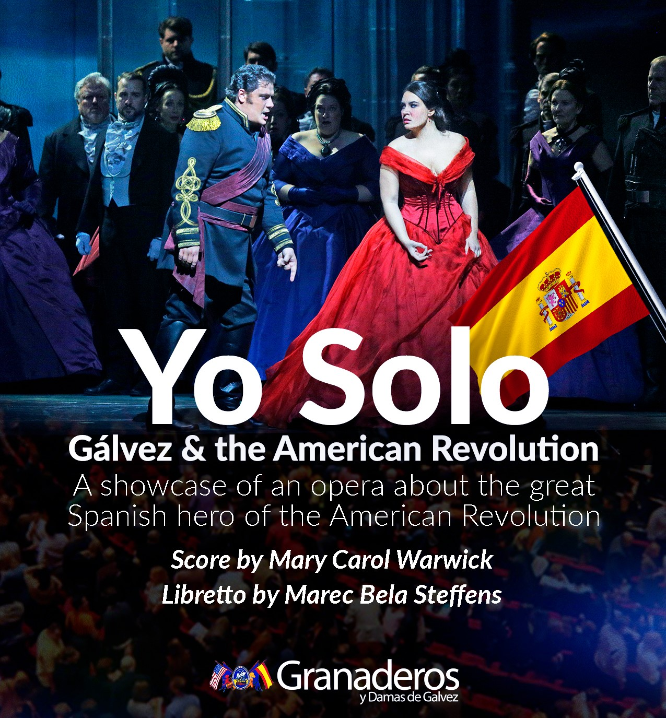

Yo Solo is an opera about the life of Gálvez. It was commissioned by the Houston Order of Granaderos and Damas de Gálvez. The brilliant Mary Carol Warwick is composing the score and is setting the witty and remarkable libretto by Marec Bela Steffens to music! The premiere is scheduled for spring 2019 in Houston and Galveston. A brief synopsis recorded at Rice University in October 2018 will be presented.

Third, the Statue:

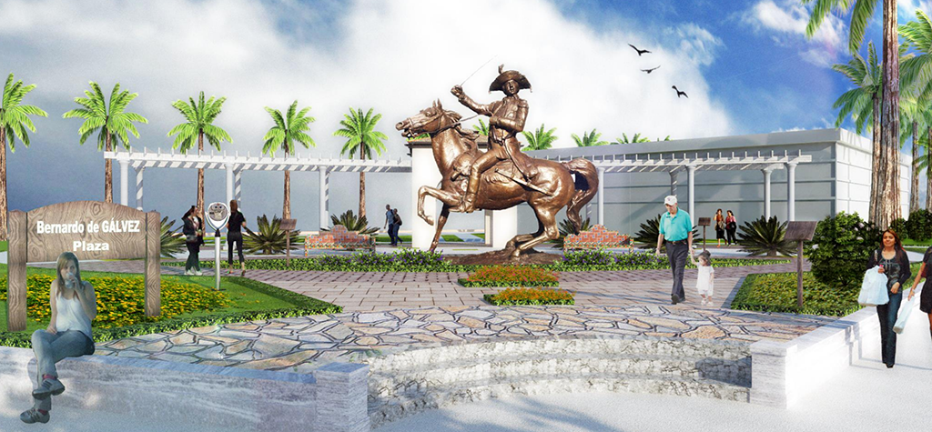

The City of Galveston, named after Gálvez, and a key Southern port in XVIII and XIX centuries, has offered a major city plaza at Seawall Boulevard and 27th Street to be renamed Bernardo de Gálvez Plaza. This area receives over six million visitors a year. There, in a warm, seaside environment surrounded by luscious palm trees, a larger-than-life-sized, equestrian monument of Gálvez will be erected in honor of Spain’s great hero of the American Revolution.

The Sons of the American Revolution and the Granaderos y Damas de Gálvez have retained renowned Texas sculptor Eric Kaposta to design the project. Bill Adriance, the project chair, will explain the design elements of Gálvez Plaza, and he will review the production plan, financing, and schedule for inauguration of the plaza.

